

Get hands on with

Asset Centric Service







Attendee Guide

Product Service Campaign and Actionable List Configuration Guide
Index

Get hands on with Connected Assets, Vehicles and Asset Centric Service 1
Product Service Campaign and Actionable List Configuration Guide 2
​🪧 Actionable List Configuration Guide 3
🛠️ Data Processing Engine Configuration 5
🪧 Actionable List Configuration continued 18
🪧 Actionable List Creation 23
🛠️ Product Service Campaign Configuration 26
Want to learn more? 31

​🪧 Actionable List Configuration Guide
Guided steps to create Actionable lists powered by data processing engine to create Asset or Vehicle data sets

1. 1. Click the Gear 2. Click on Setup…
Access setup from any page in your org
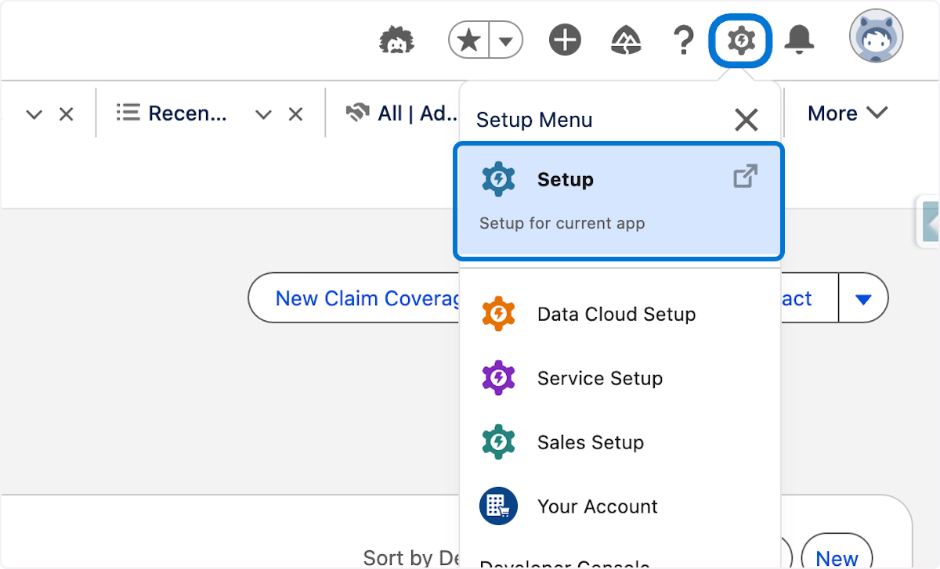

2. 1. In setup quick search Type "Actionable" 2. Click Actionable Segmentation Settings
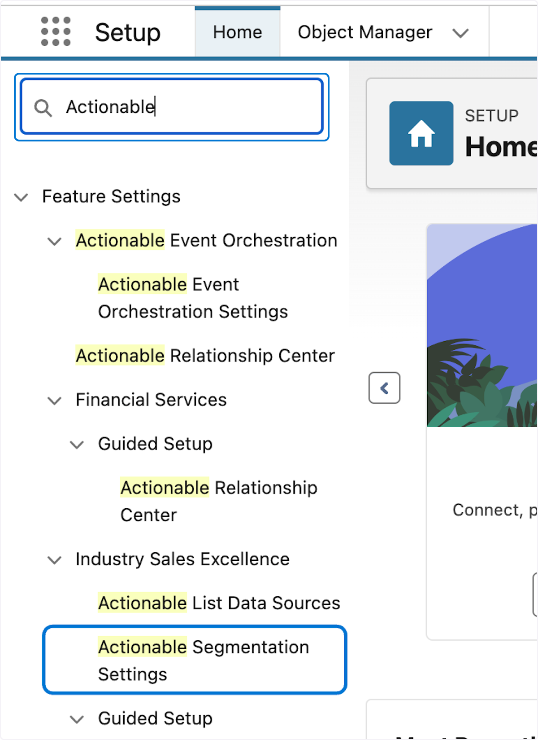

3. 1.Click on New Data Processing Engine Definition
Data processing engine is an industry provided platform data transformation and aggregation component.
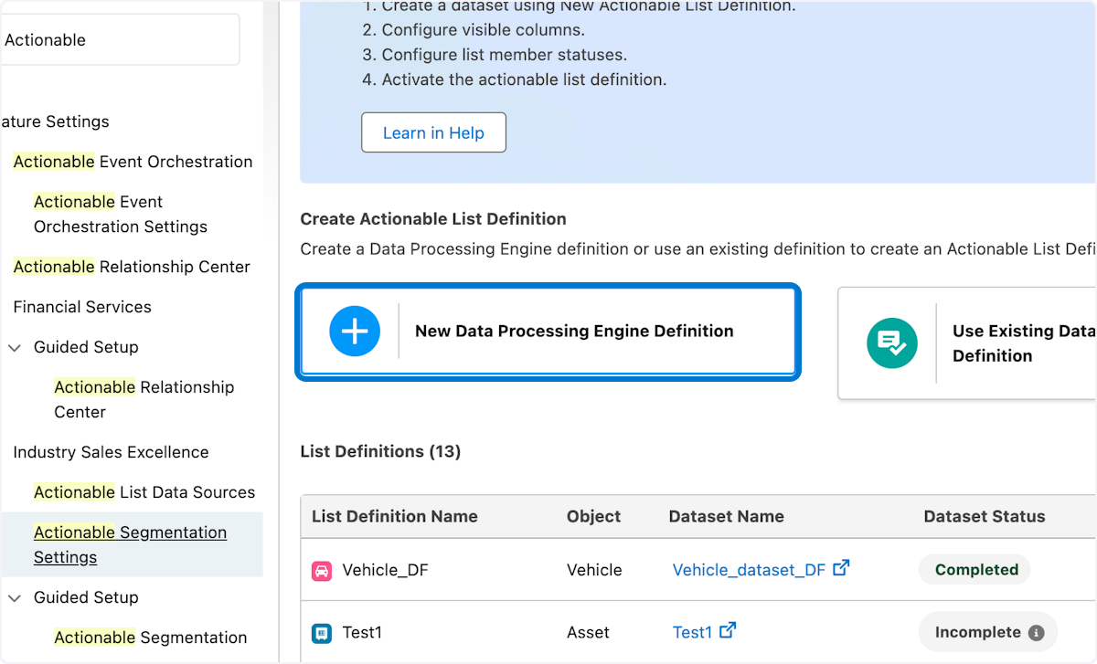

4. 1. Type "WorkshopAssetServiceEOLUpgradeCampaign" 2. Pick Asset from the object list 3. Click on Save & Next
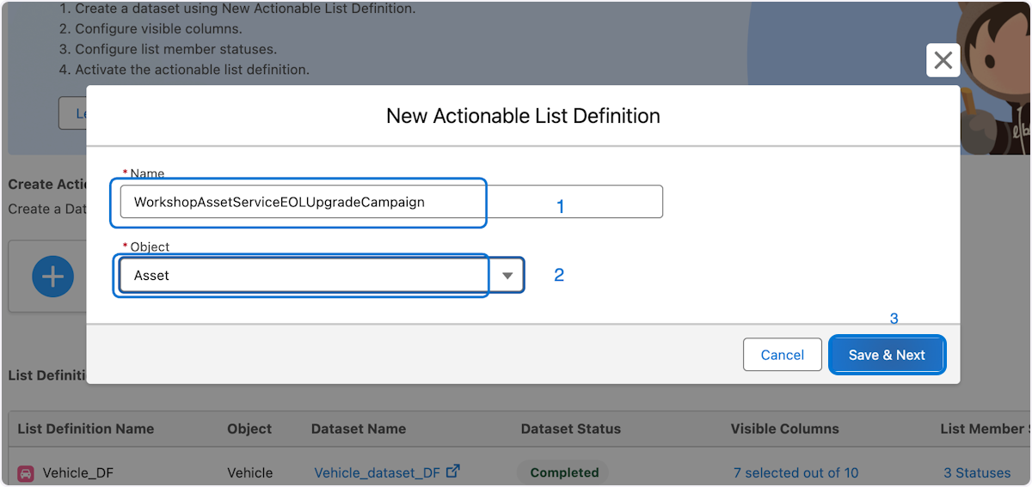

5. Click on Launch Data Processing Engine
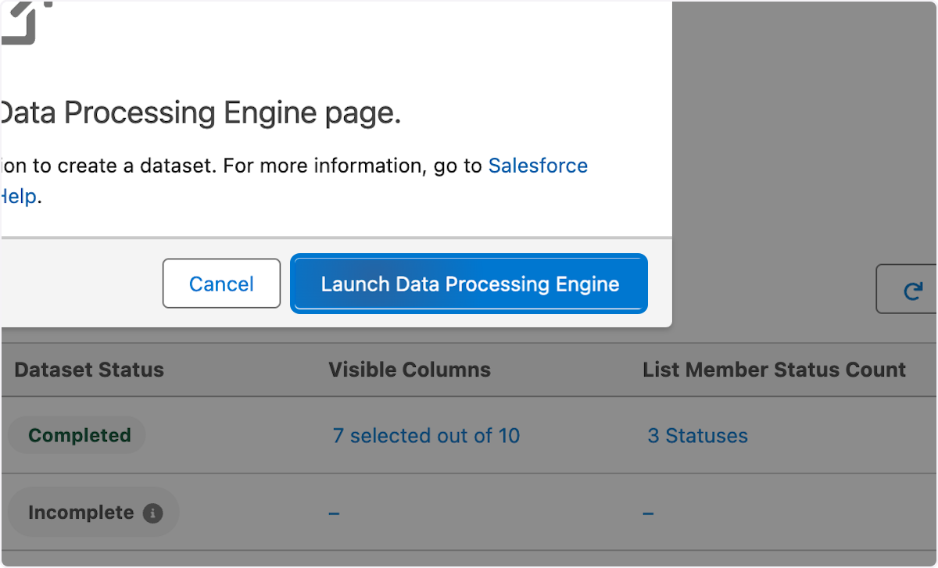

🛠️ Data Processing Engine Configuration
Configure the new context definition for Assets

6. 1. Click the Asset_DS Data Source 2 .Click on Configure
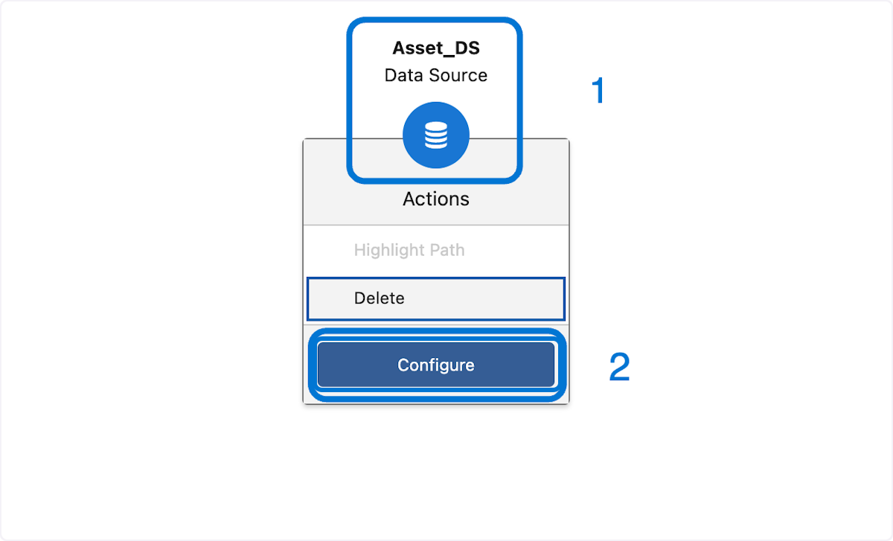

7.1. Click on Selected Fields (2) button
Here we will choose all the fields for asset that we may want to use for the campaign and other nodes like a join
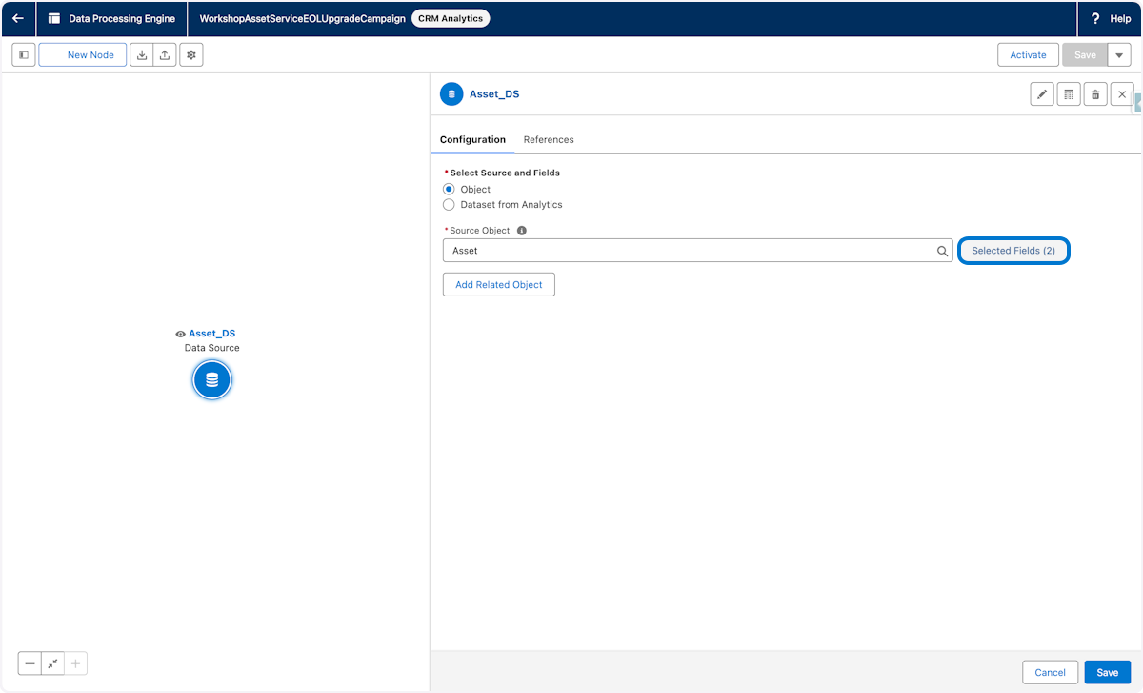

8. 1. Select the fields from Asset as shown 2. Update the alias names where shown 3. Click Save
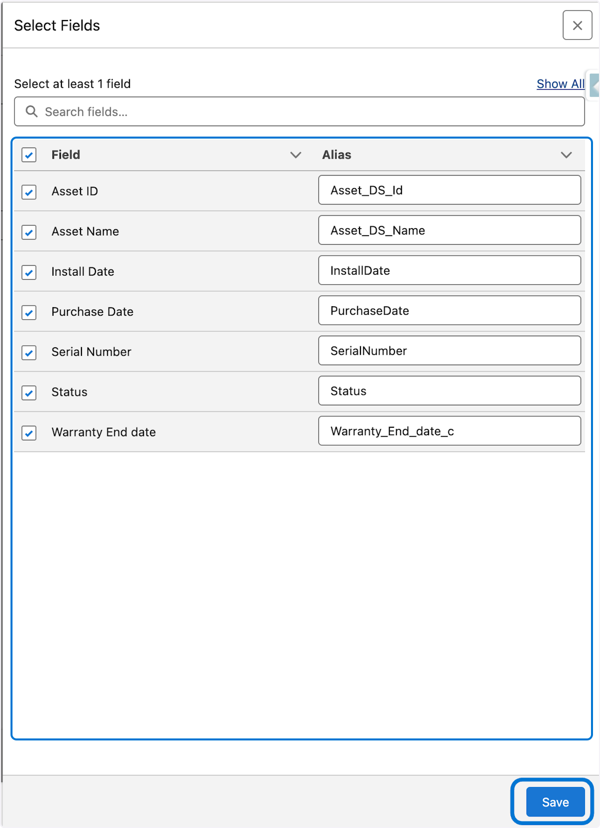

9. 1. Click on Save for the Asset node
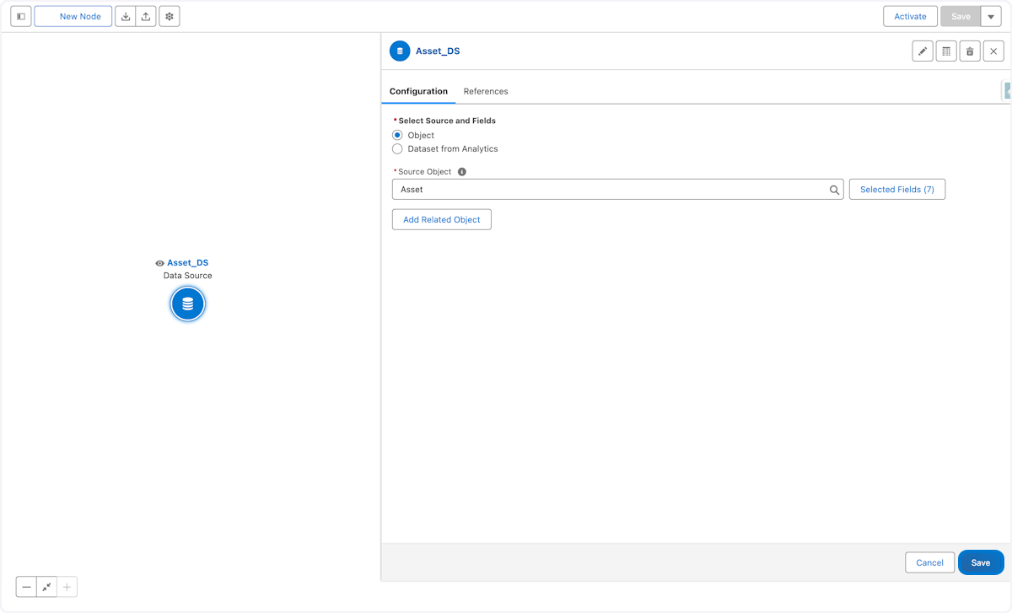

10. Click on New Node
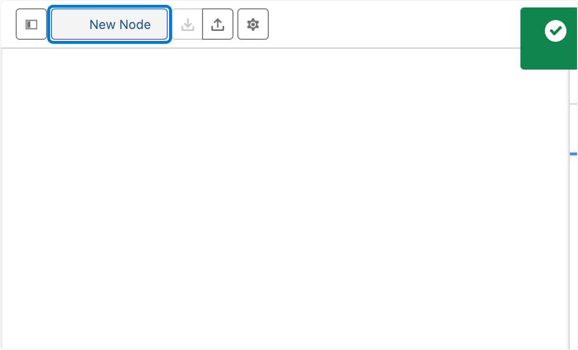

11. 1. Choose Data Source for Node Type 2. Type AssetWarranty_DS in Name field 3. Click in the API Name field to auto populate the API Name 4.Click on Save
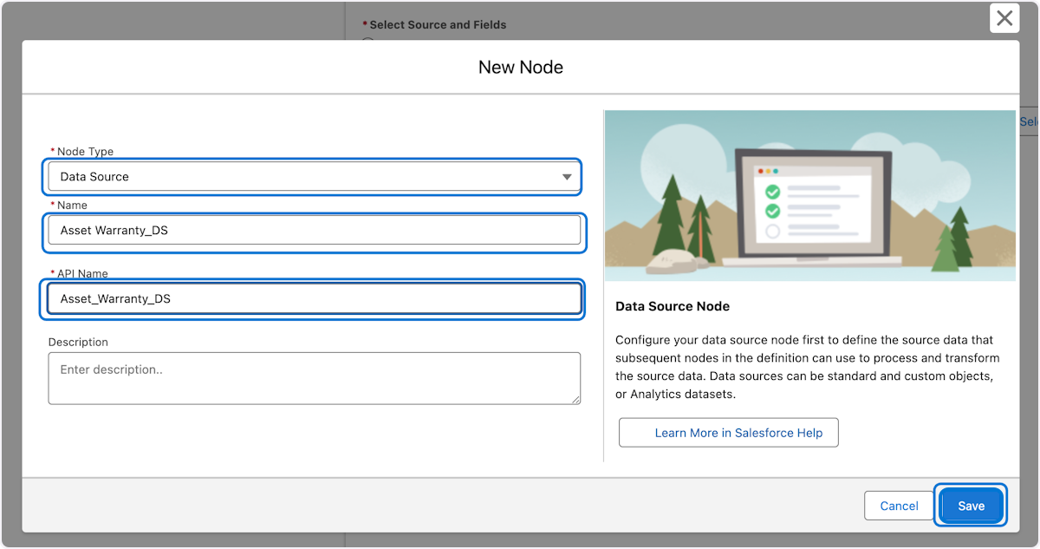

12. 1. Type "Asset Wa" and select Asset Warranty Entity form source object field
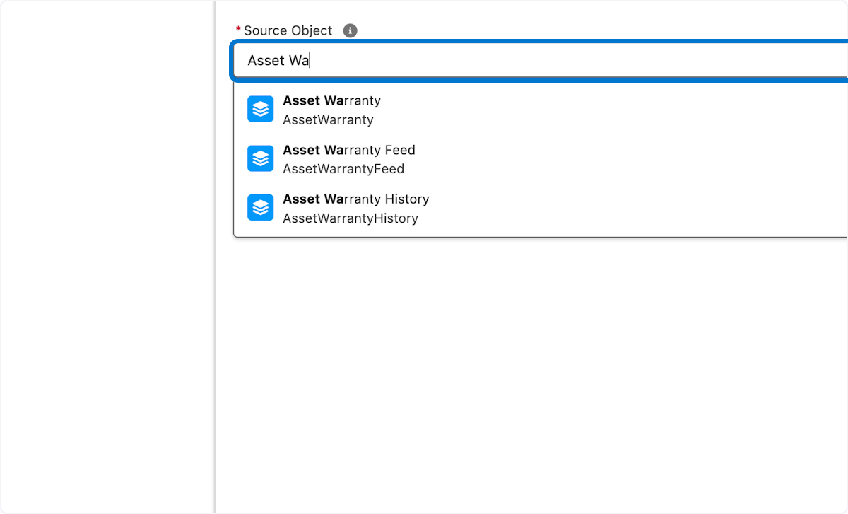

13. Click on Select Fields of Asset warranty
Here we will choose all the fields we may want to use from Asset Warranty entity in the data set.
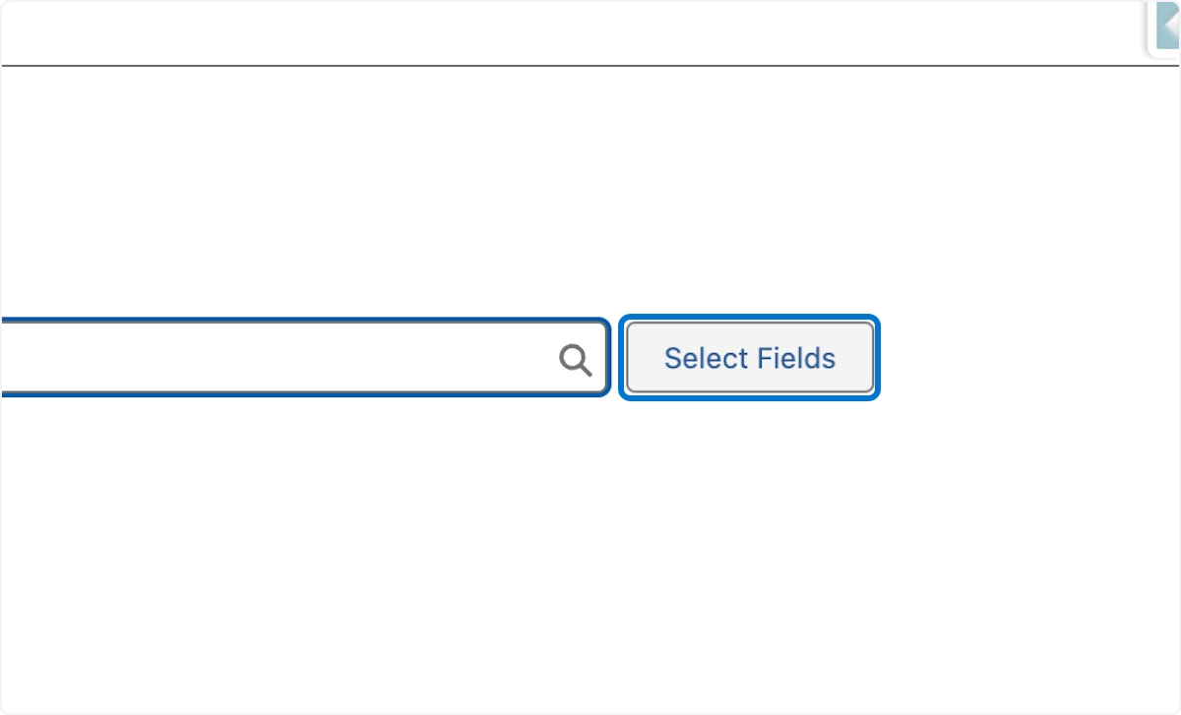

14. 1. Select the fields from asset warranty object as shown 2. Update the alias names where shown 3. Click Save
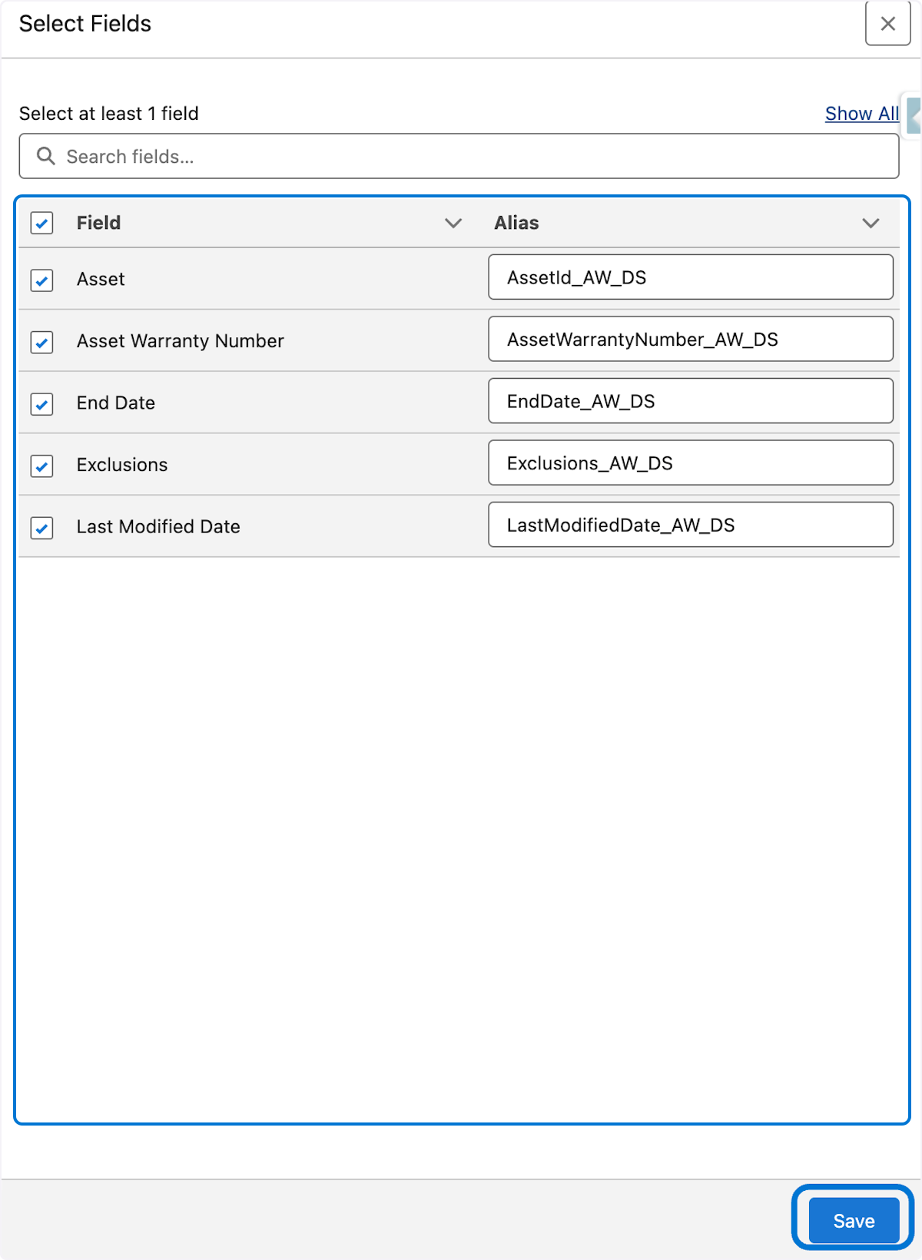

15. 1. Click on Add Related Object from the Asset Warranty Configuration page
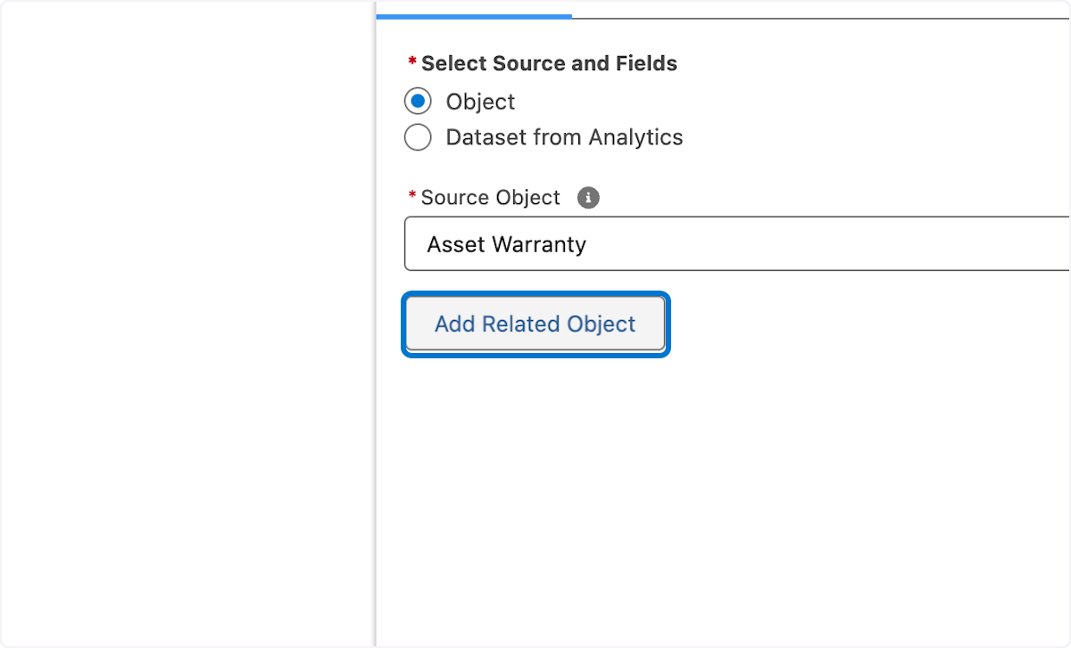

16. 1. Click on Related Object
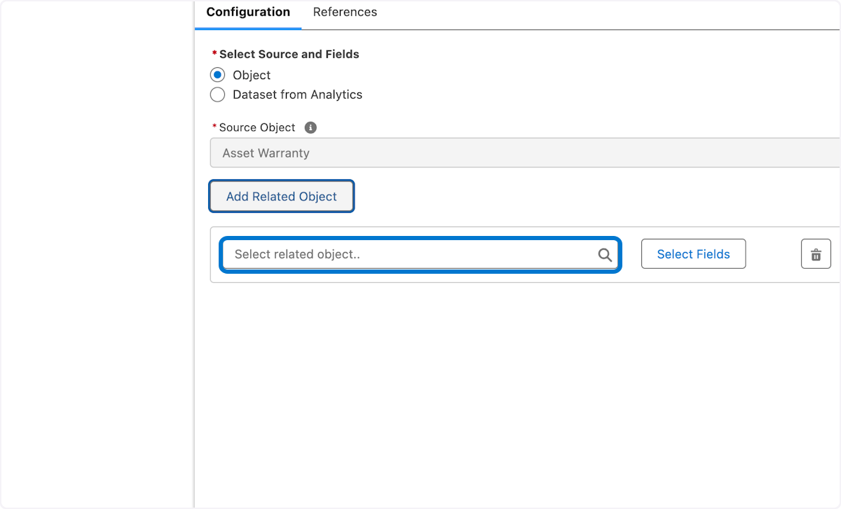

17. 1. Click on Add Related Object button from the Asset Warranty Configuration page 2. Choose Asset from the related object field 3. Click the Select fields button
Here we chose related fields from asset within Asset Warranty
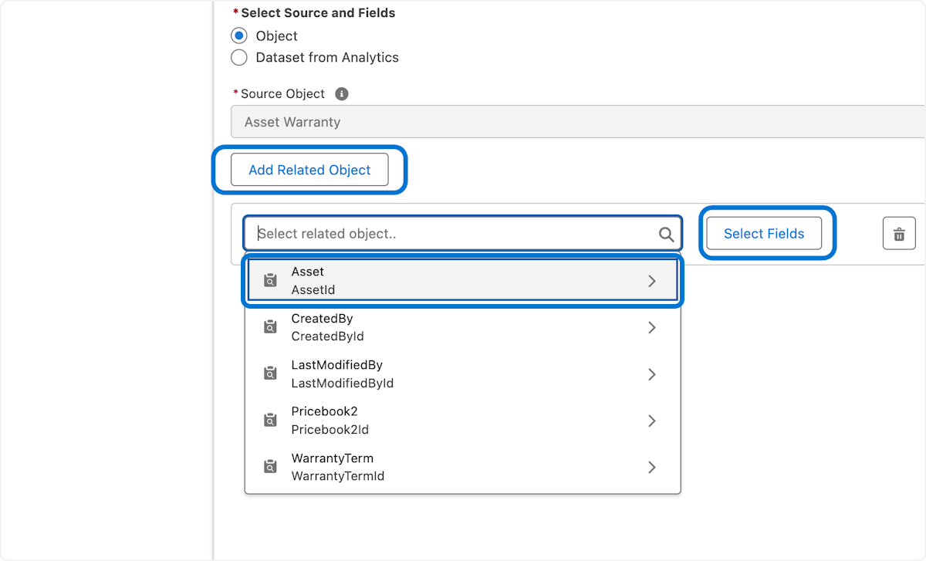

18. 1. Select the field from asset related object as shown 2. Update the alias names where shown 3. Click Save
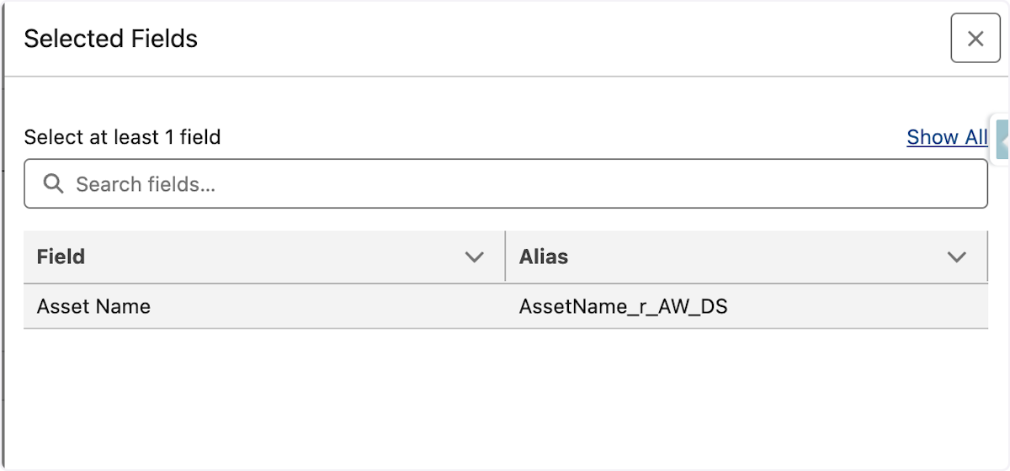

19. Click on Save again to save the Asset Warranty Node
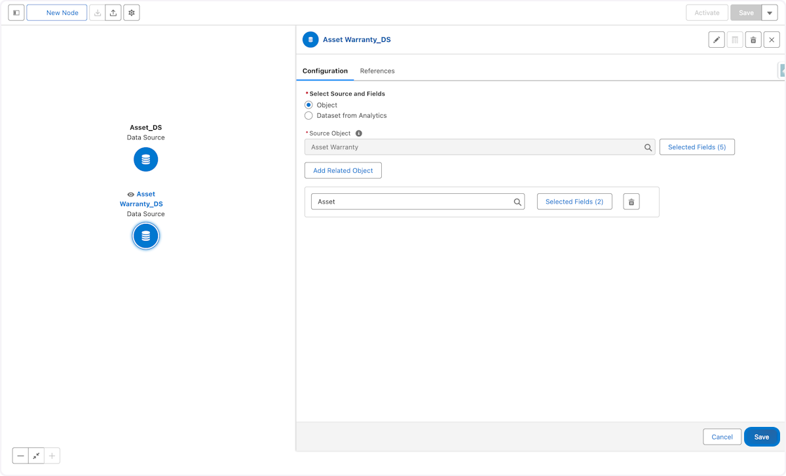

20. 1. Click on New Node
In the next few steps we will join the two data source nodes together
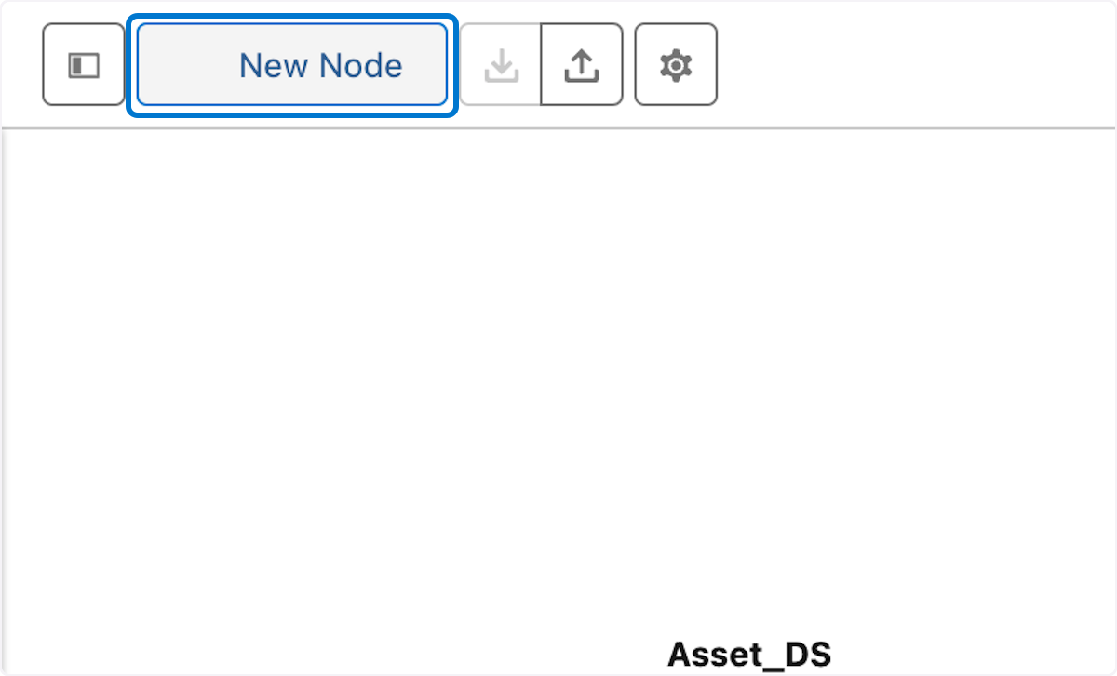

21. 1. Choose Join for Node Type 2. Type "Join Asset to Asset Warranty" in Name field 3. Click in the API Name field to auto populate the API Name 4. Click on Save
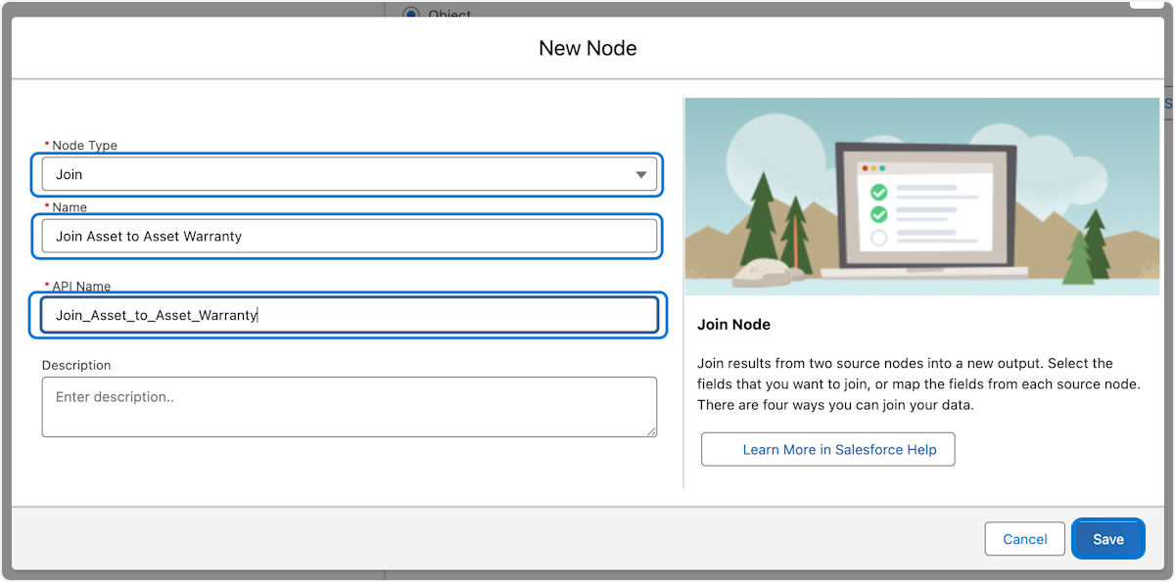

22. 1. In the first node choose Asset_DS 2. In the second node choose Asset Warranty _DS
Here we actual perform the join for the two selected objects
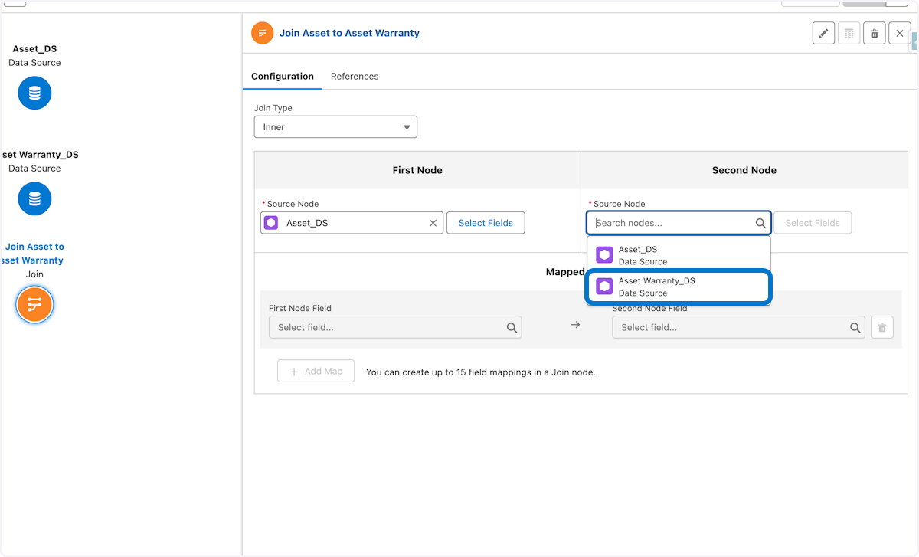

23. 1. Click on Select Fields button next to the source node Asset_DS
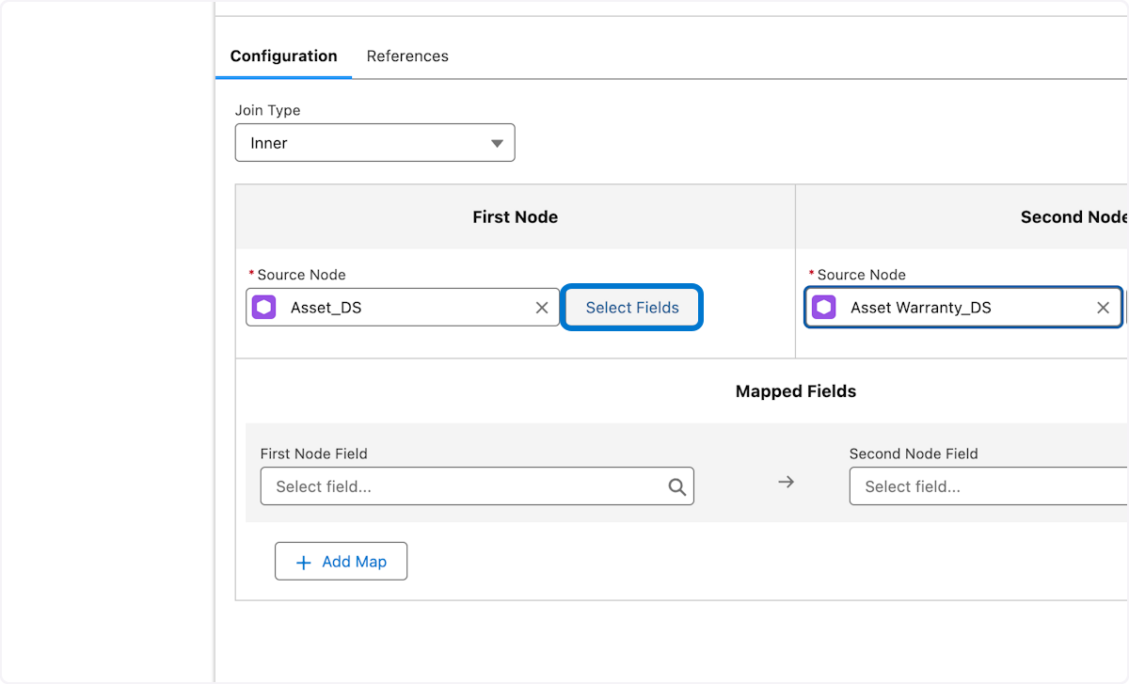

24. 1, Check Select All checkbox 2. Click Save
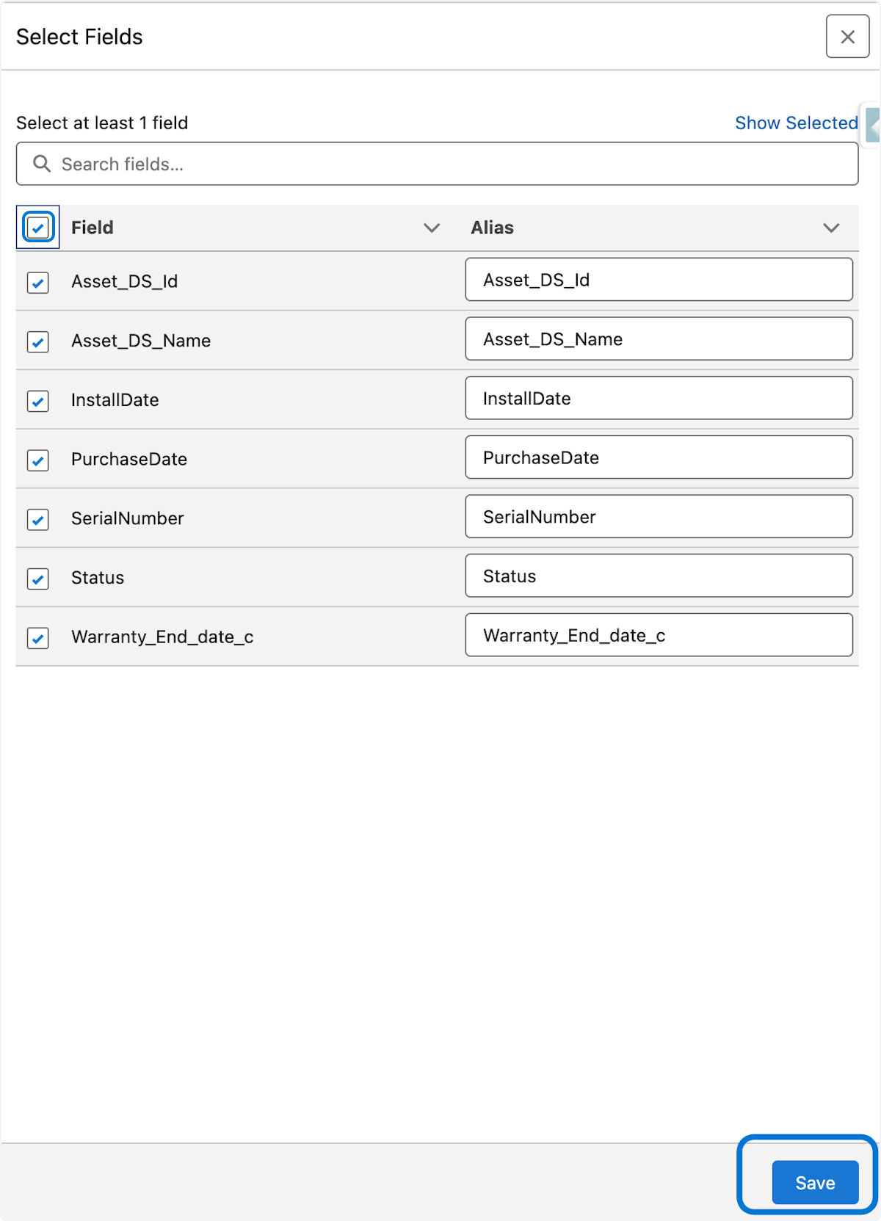

25. 1.Click on Select Fields button next to the Asset Warranty _DS source node
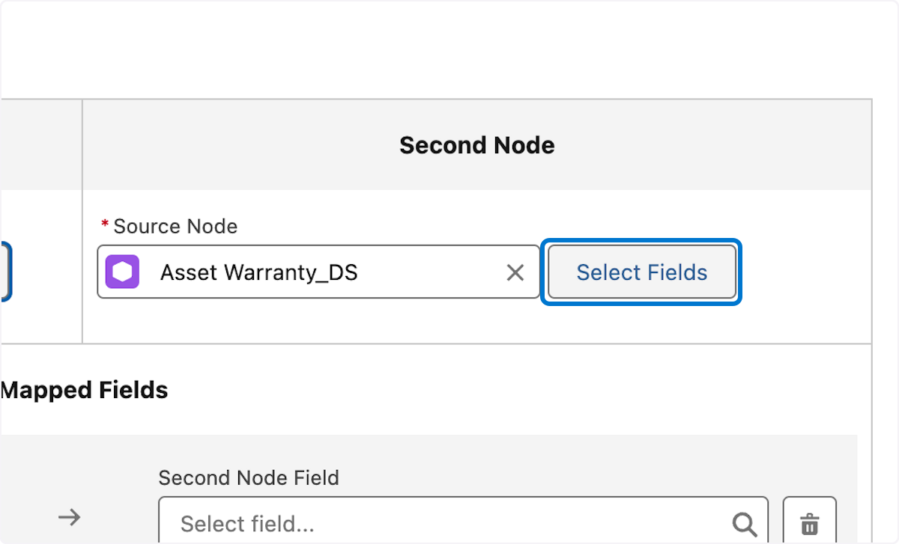

26. 1. Check Select All checkbox 2. Click Save
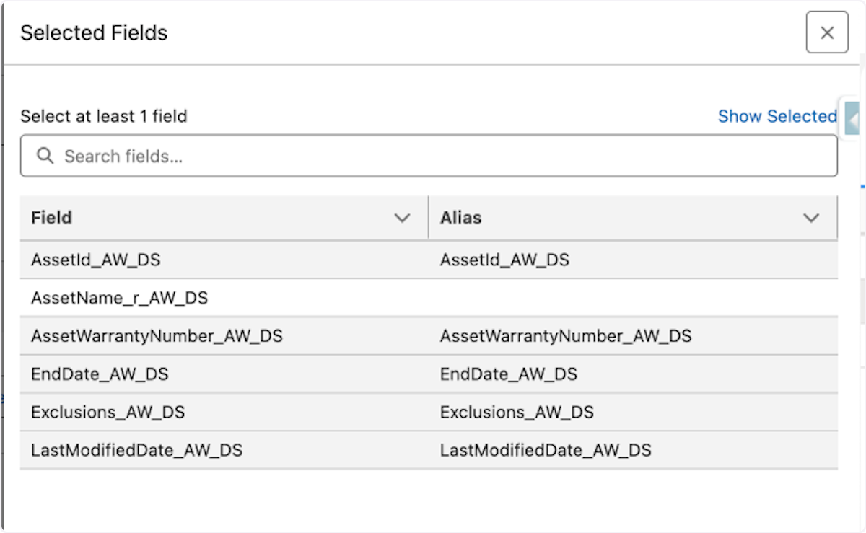

27. Click on First Node Field
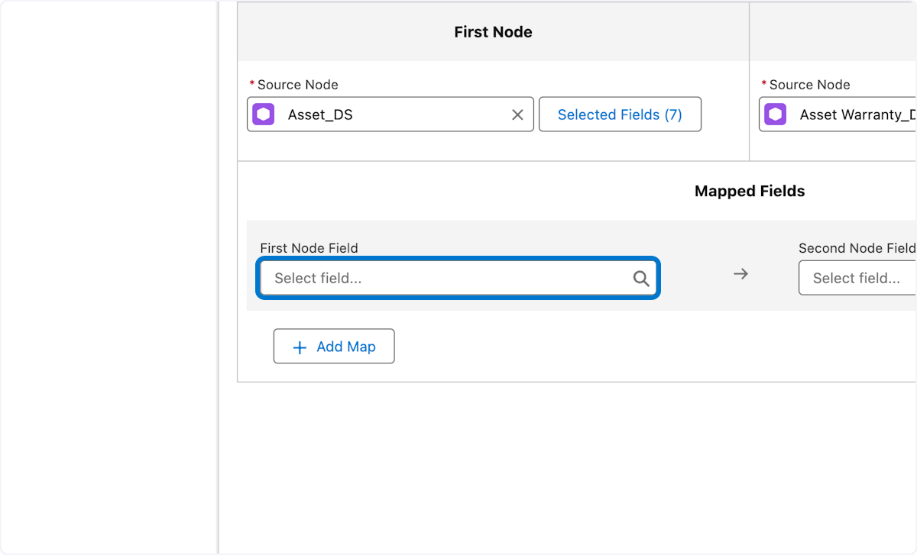

28. 1. In the mapped fields section select Asset_DS_id from First Node Field 2. Select AssetId_AW_DS from the Second Node Field 3. Click Save
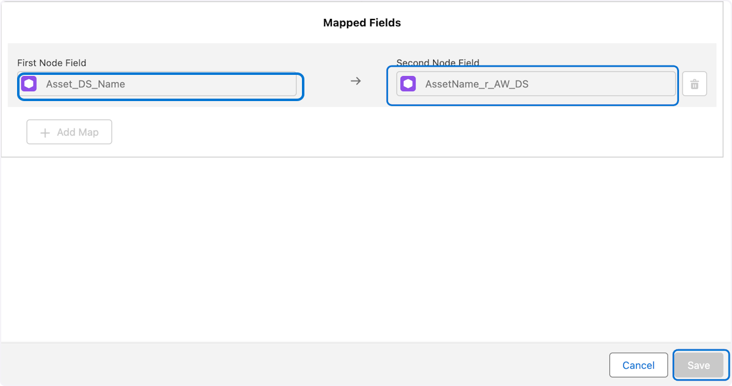

29. 1.Click on New Node
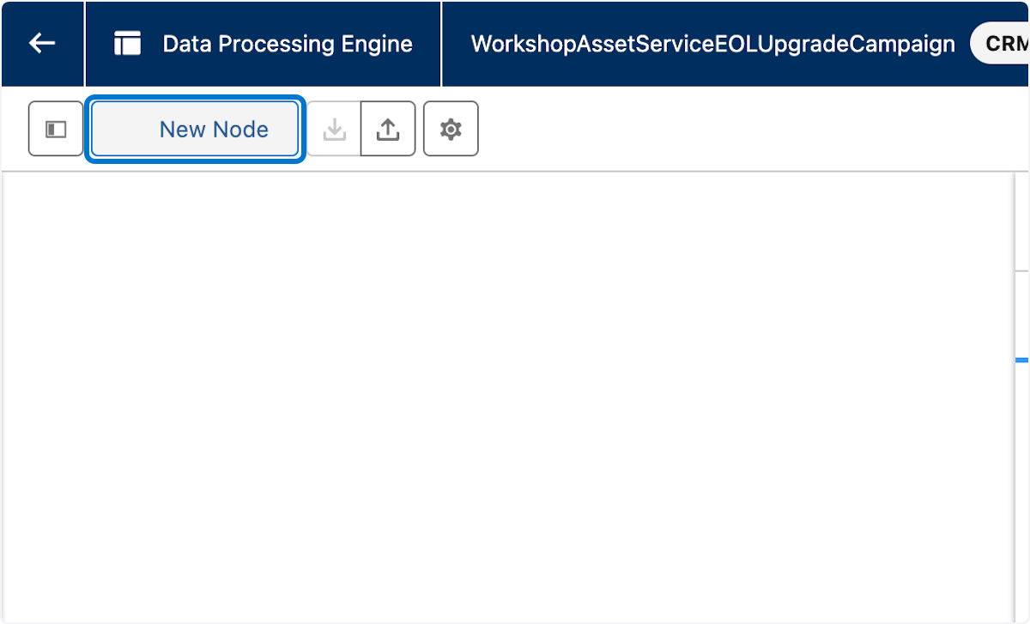

30. 1. In Node Type select Writeback Object 2.In Name Type "Asset Warranty EOL Campaign WriteBack" 3. Click the API Name to auto populate the API Name 4. Click Save
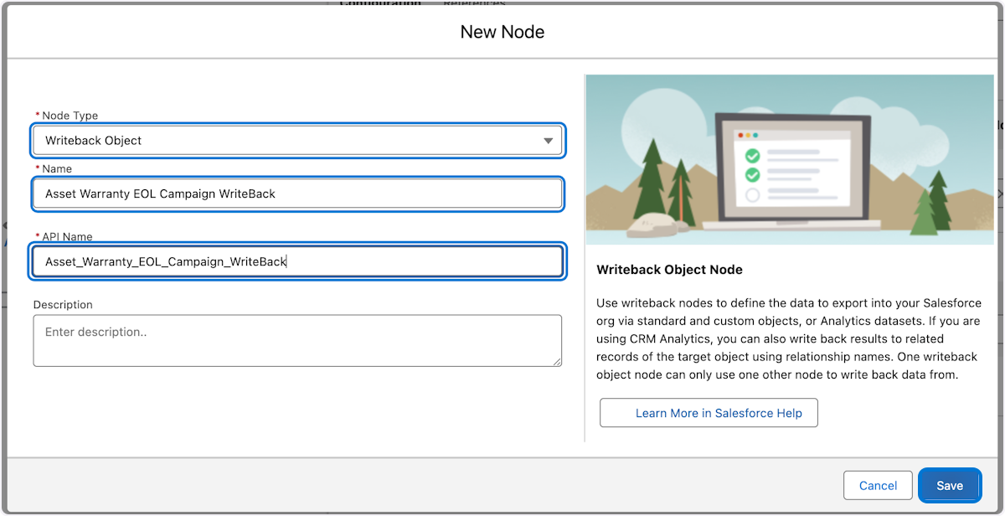

31. 1. In the source node within the writeback configuration, choose Join Asset to Asset Warranty join node 2. Select the radio button for Analytics in Target Type 3. Type "WorkshopAssetServiceEOLUpgradeCampaign" into Dataset Name field
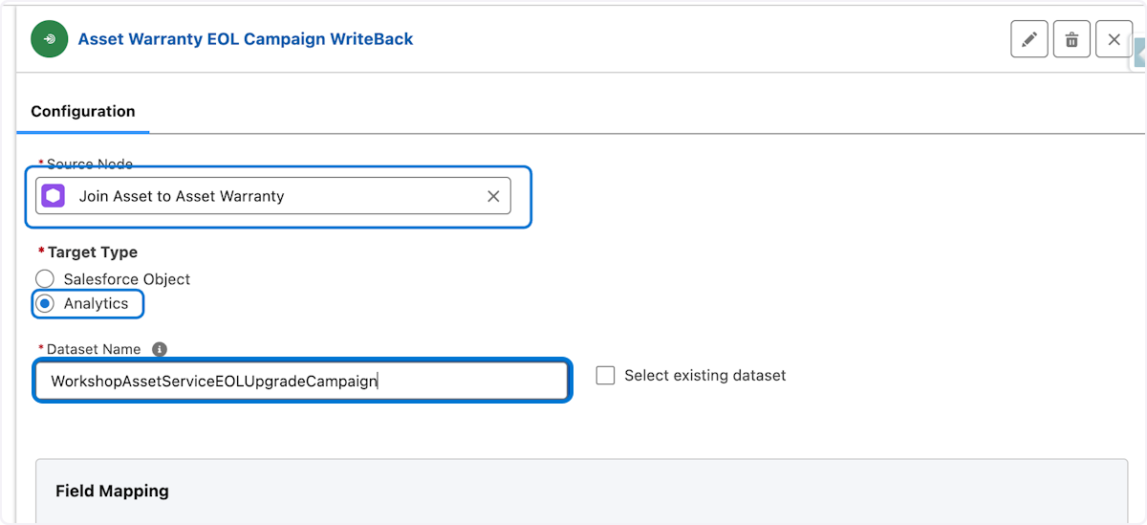

32. 1. In the Field Mapping section select all the fields adding rows as needed
🛑In this sections simply click each field in the drop down and click the add button until all fields are used
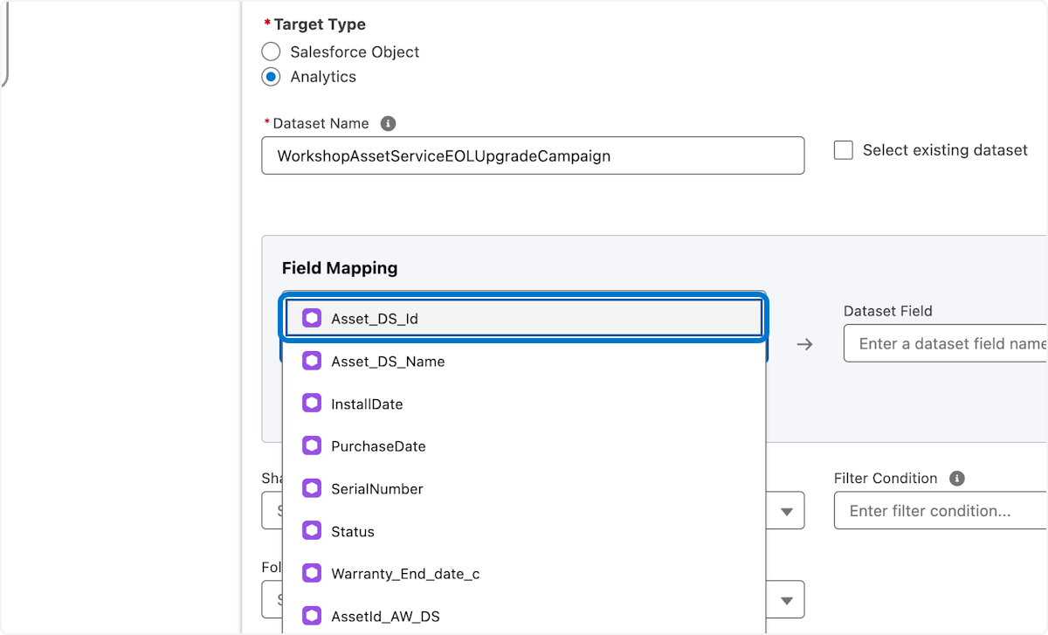

33. 1. At the bottom for Field Mappings choose Folder Name ActionableSegmentation 2. Click Save
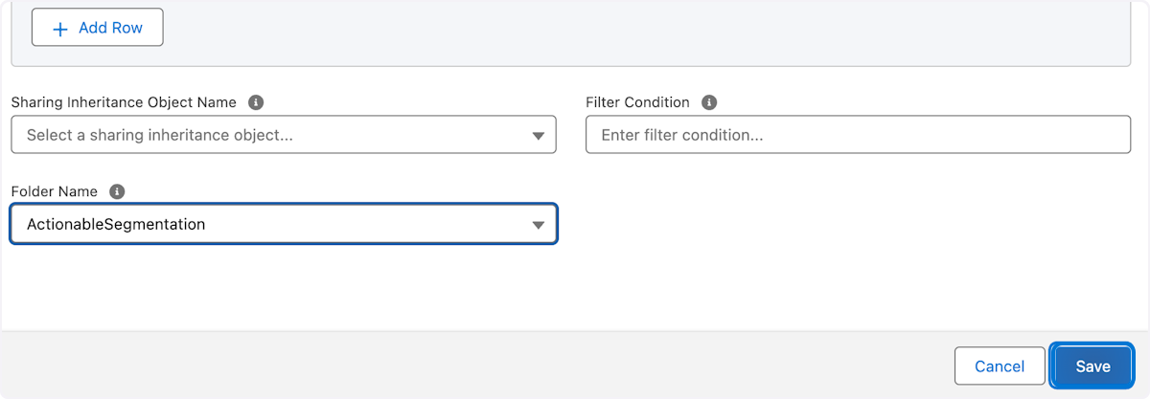

34. 1.Click on Save on the Top right to save the Data processing engine definition 2. Click Activate
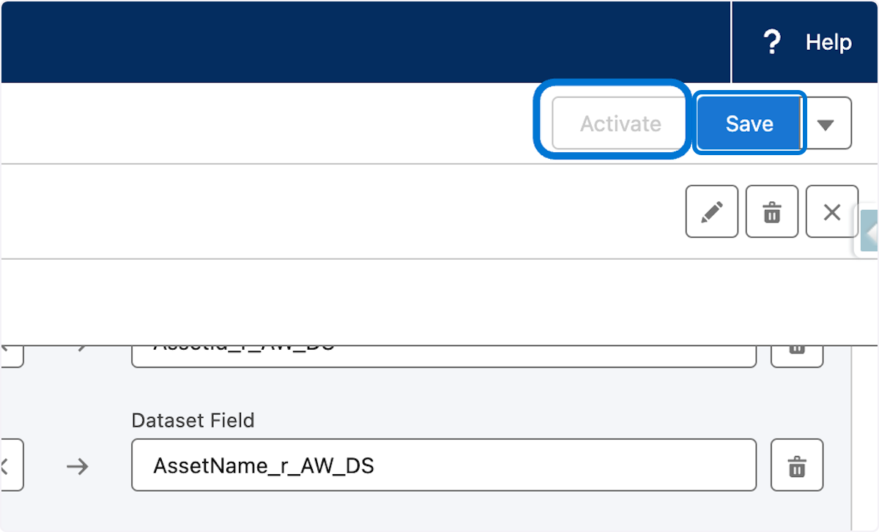

35. 1. Click on Run Definition
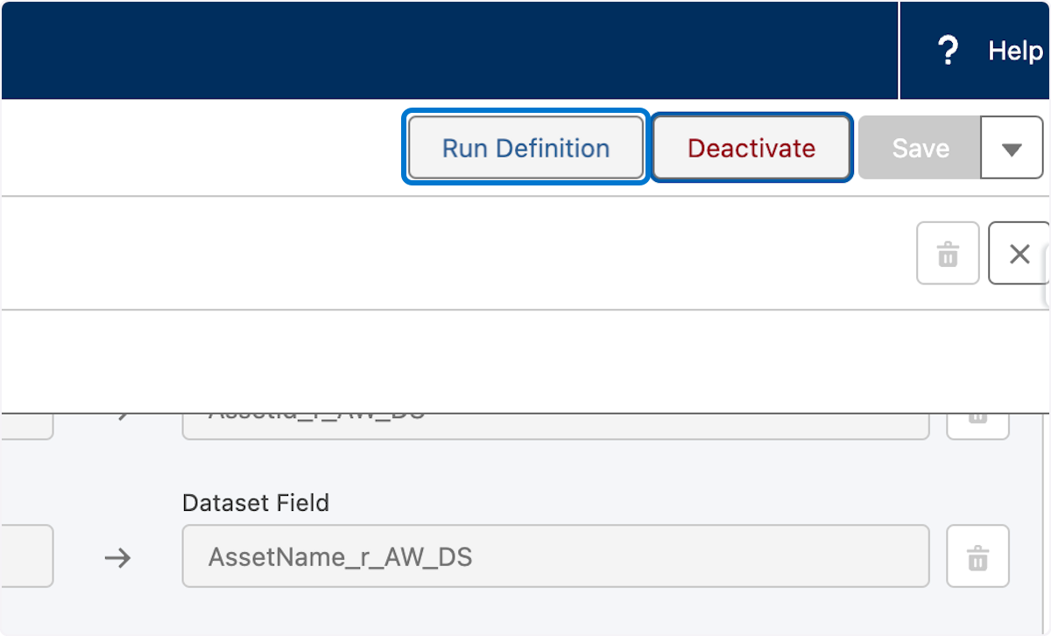

36. 1. Click Next through the wizard accepting defaults
This completes the data processing engine portion to build out the dataset
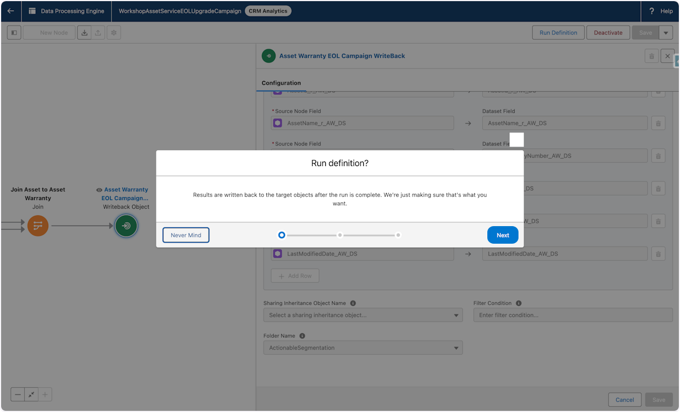

🪧 Actionable List Configuration continued

37. 1. Click Setup gear 2. In setup quick search Type "Actionable" 3. Click Actionable Segmentation Settings

Navigate Back to the Actionable Segmentation Settings


38. 1. Click on Refresh Dataset Status
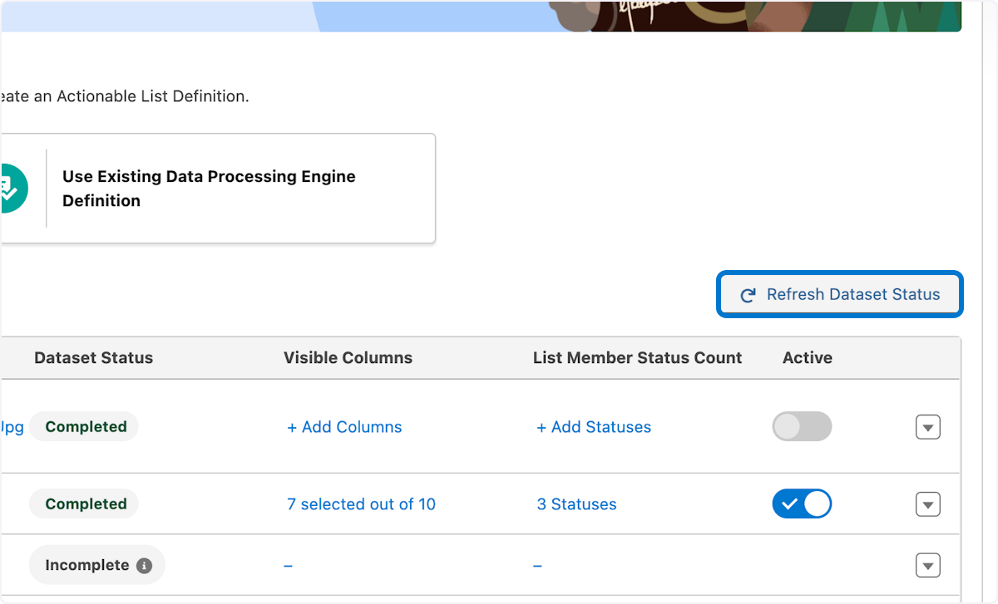

39. 1. In the workshop actionable list Click on + Add Columns
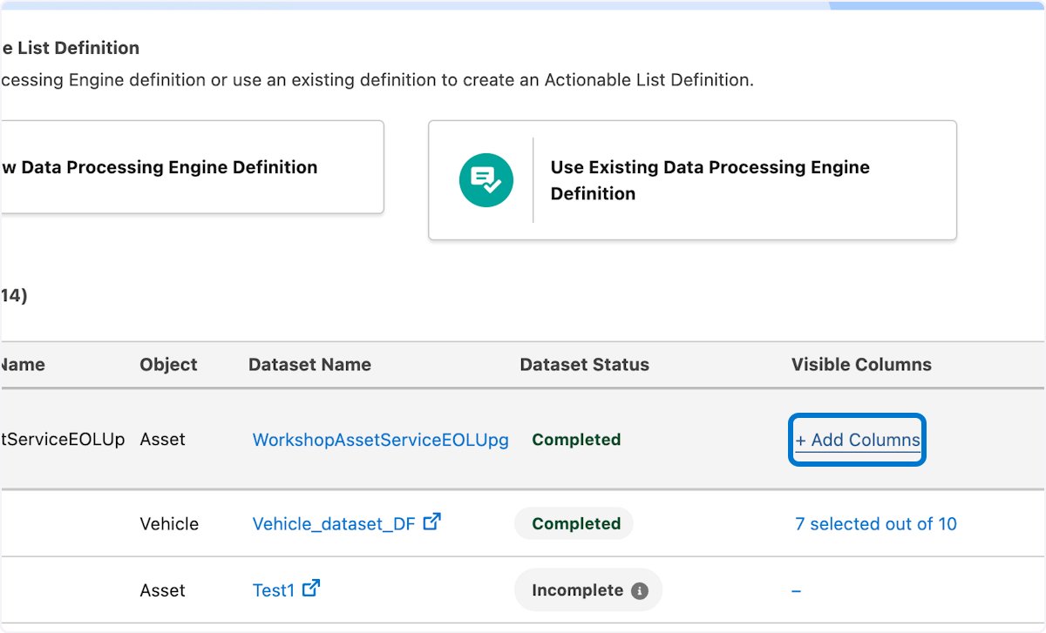

40. 1. Click the available field names and move them all to the selected field name box 2.Click on Save
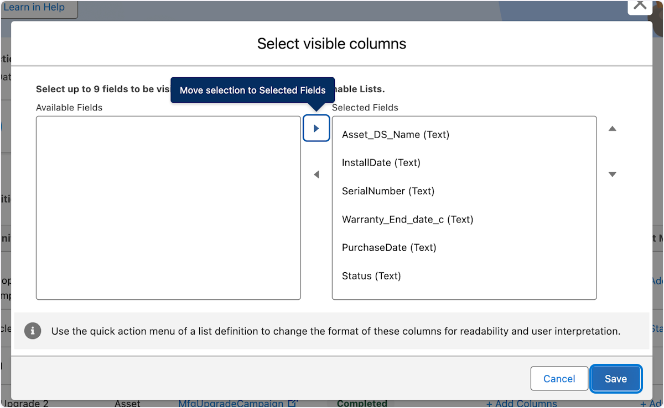

41. 1. Click on + Add Statuses
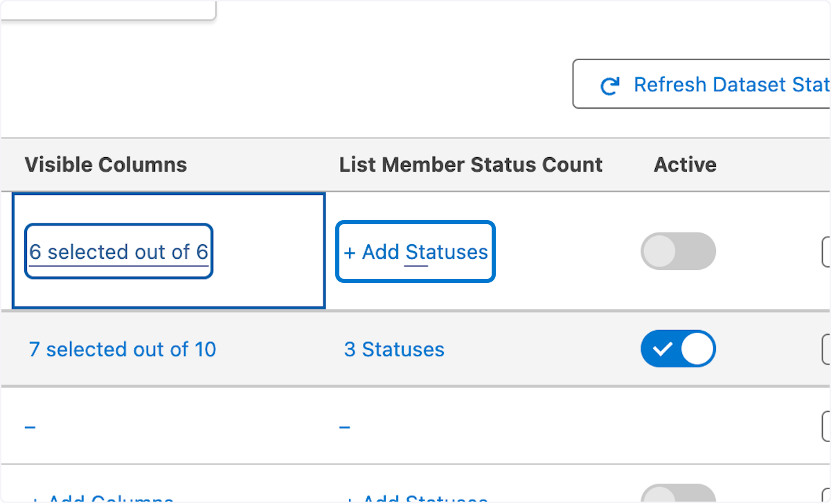

42. 1. Click New Status button and add the shown status items 2. Click save
After complete the actionable list , these are the status actions that will be available
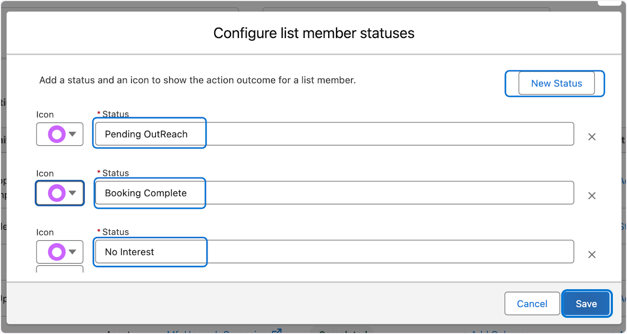

43. 1. Toggle on to activate
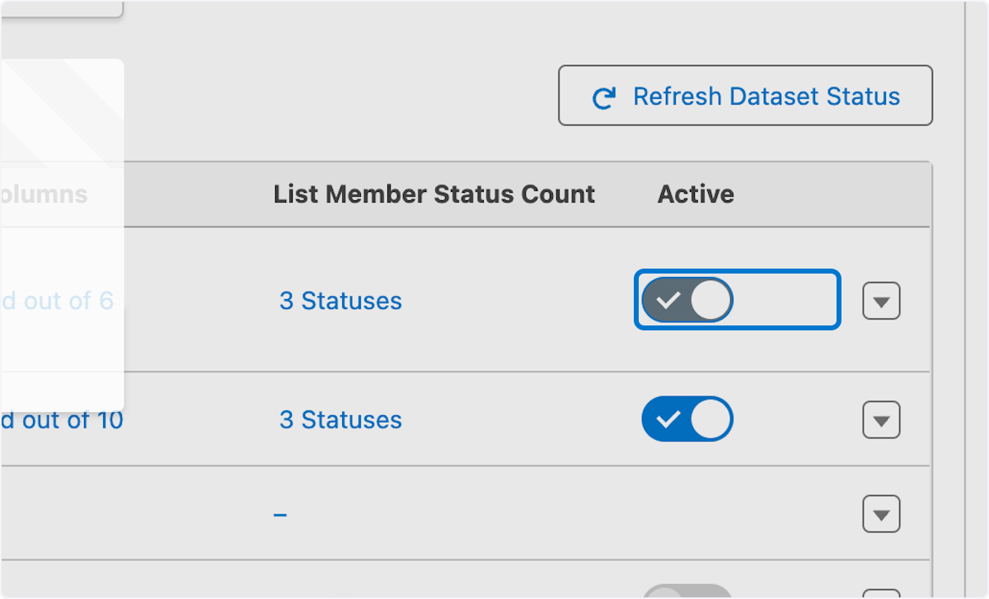

44. 1.Click on OK
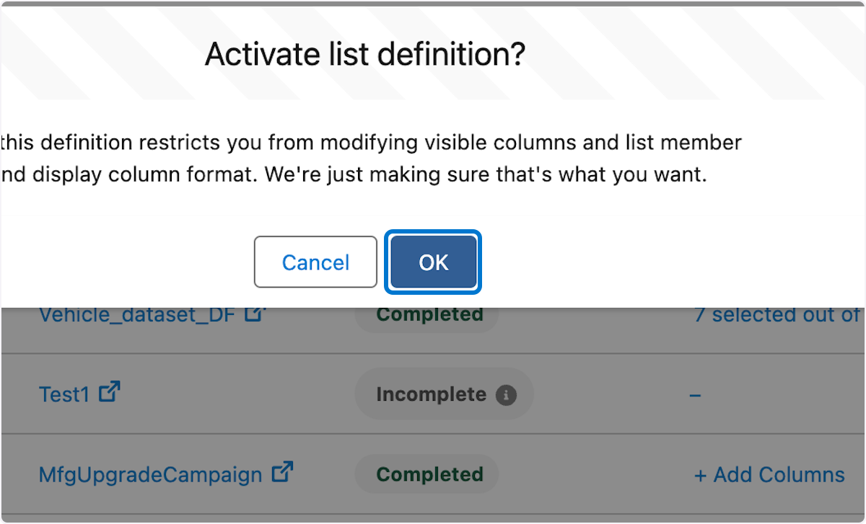

45. 1. Click the App Launcher icon 2. In search Type "Actionable List" 3. Click Actionable List
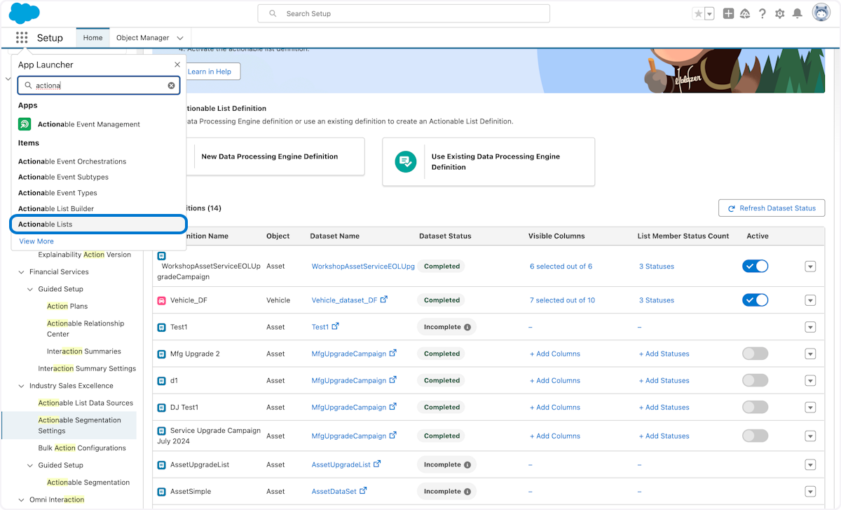

🪧 Actionable List Creation

46. Click on New to create a new actionable list
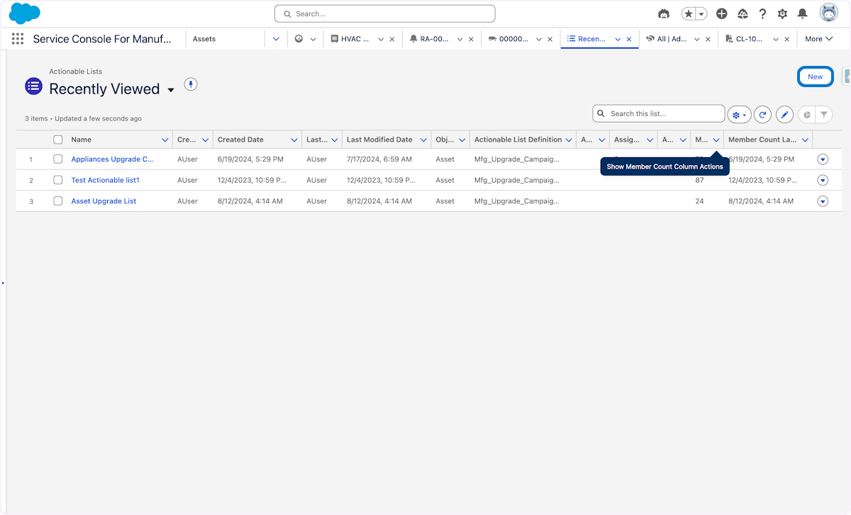

47. 1.Type Workshop Upgrade Campaign in the New Actionable List Name 2. Select the Data processing Engine definition create earlier WorkshopAssetServiceEOLUpgradeCampaign 3. Click Next
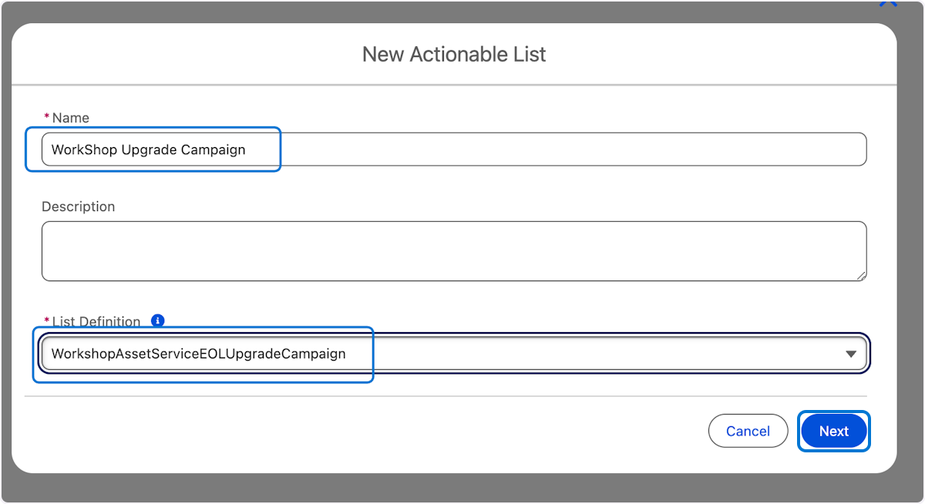

48. 1.Click the Filter Criteria 2.Choose InstallDate… 3. Choose Previous Fiscal Year 4. Click Apply
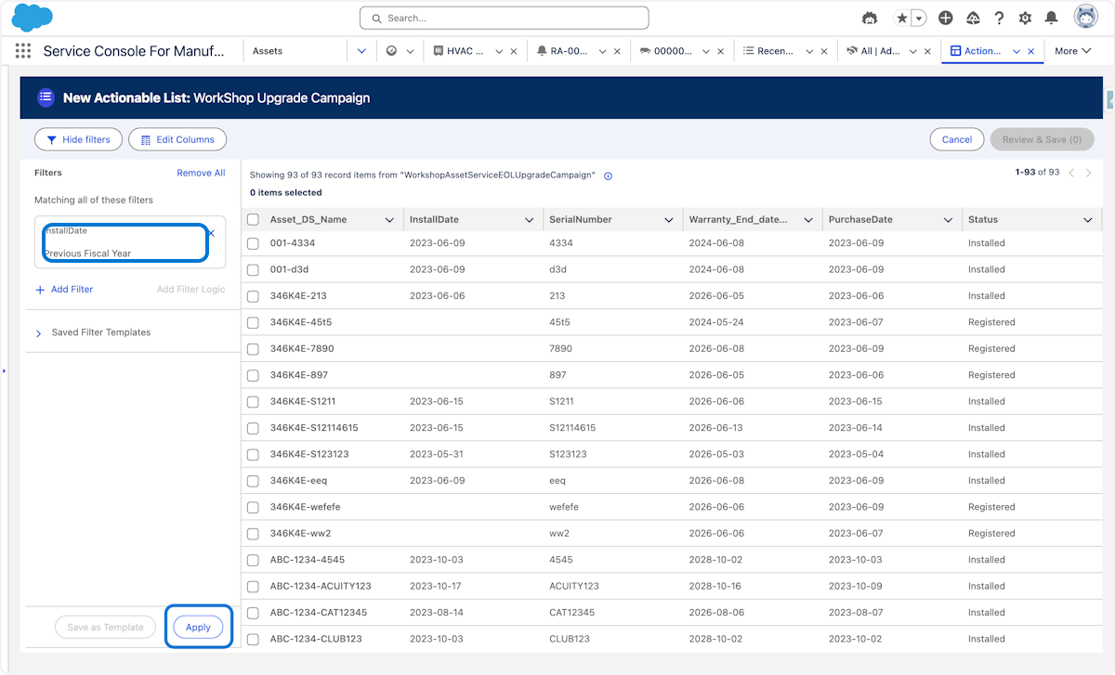

49. 1.Check Select All to select all the filtered assets
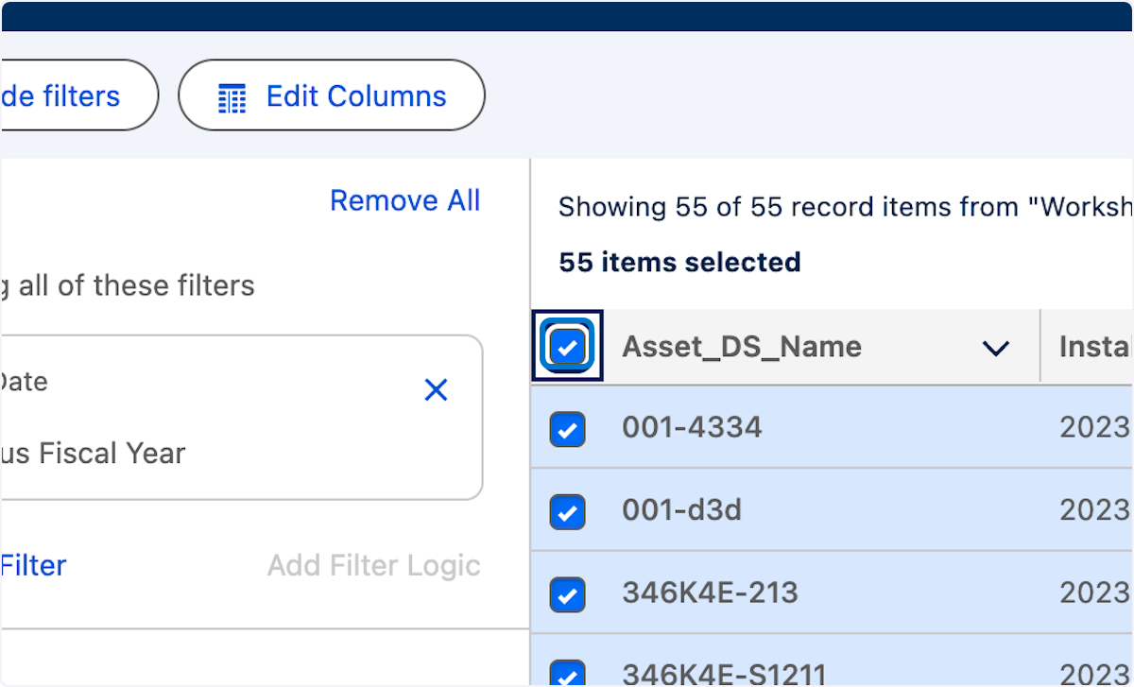

50. 1. Click on Review & Save (55)
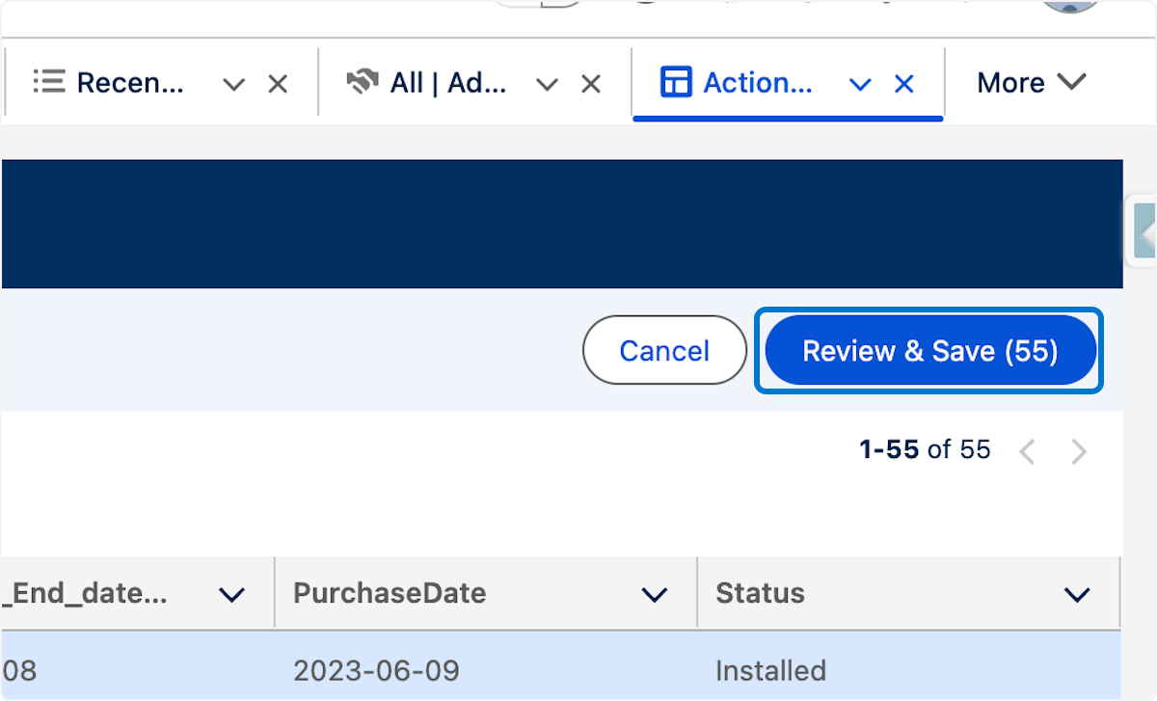

51. 1. Click on Confirm & Save
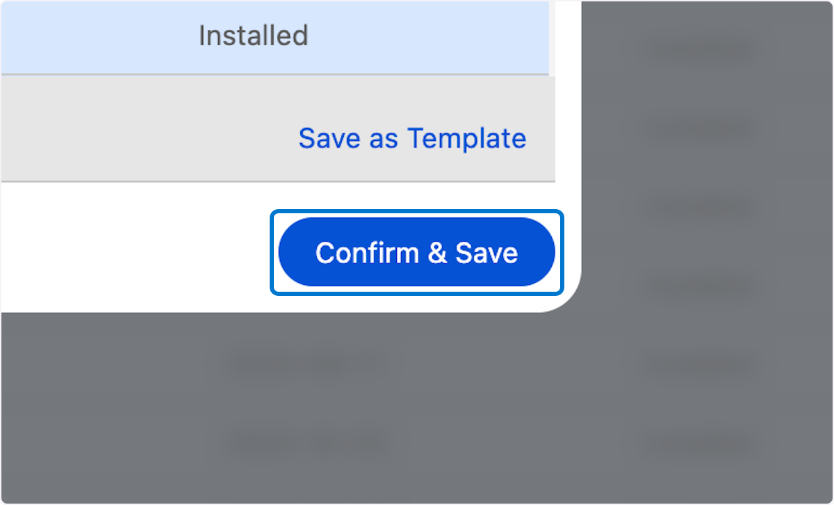

🛠️ Product Service Campaign Configuration

52. 1. From App Launcher search for Product Service Campaigns 2. Click New
Now We create a new product service campaign and connect the actionable list
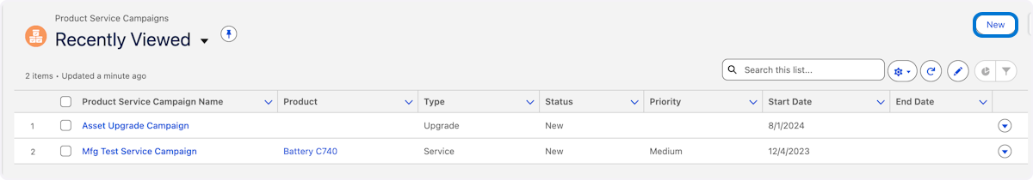

53. 1. Type "Workshop Upgrade Campaign for the Campaign Name 2. Select Upgrade from the type pick list 3. Select a work type "replace compressor" 4. In Start date choose "Today" 5. In the actionable list choose WorkShop Upgrade Campaign 6. Click Save
In this section we are connecting the campaign to the actionable list to foster integration between data sets and campaigns.
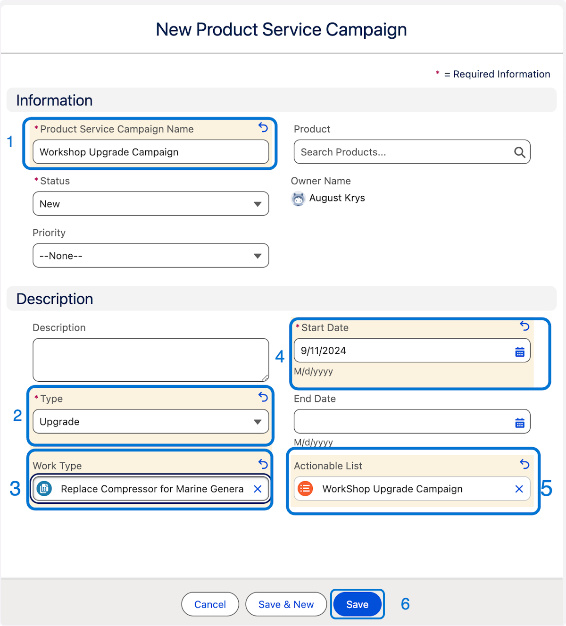

54. 1. Click the actionable list link to take you back to the Workshop Upgrade Campaign actionable list
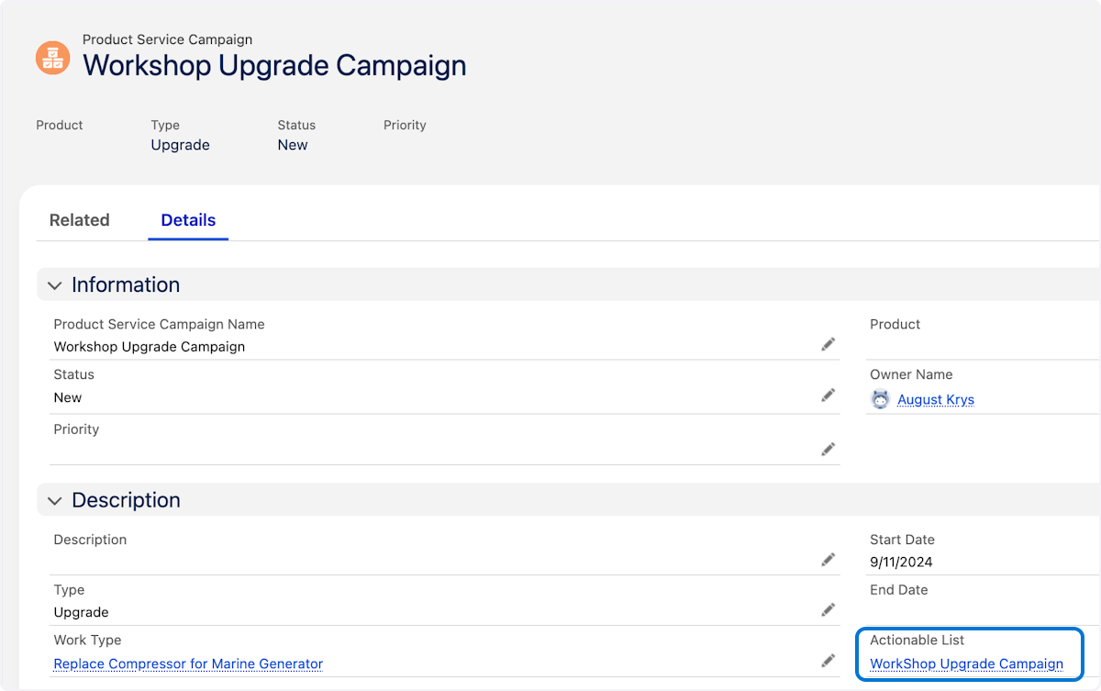

55. 1. Click the action carrot 2. Click on Add to Service Campaign
Performing this function will automatically add all the assets to the campaign.
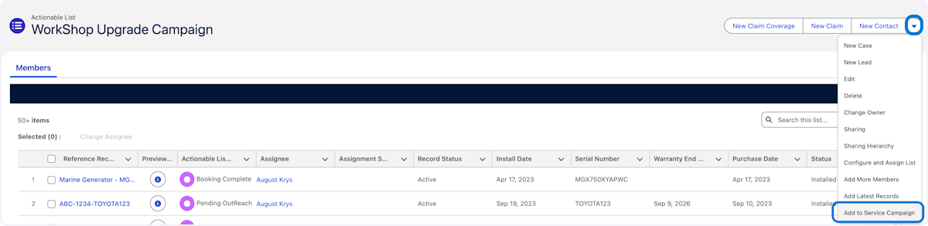

56. Click on Confirm
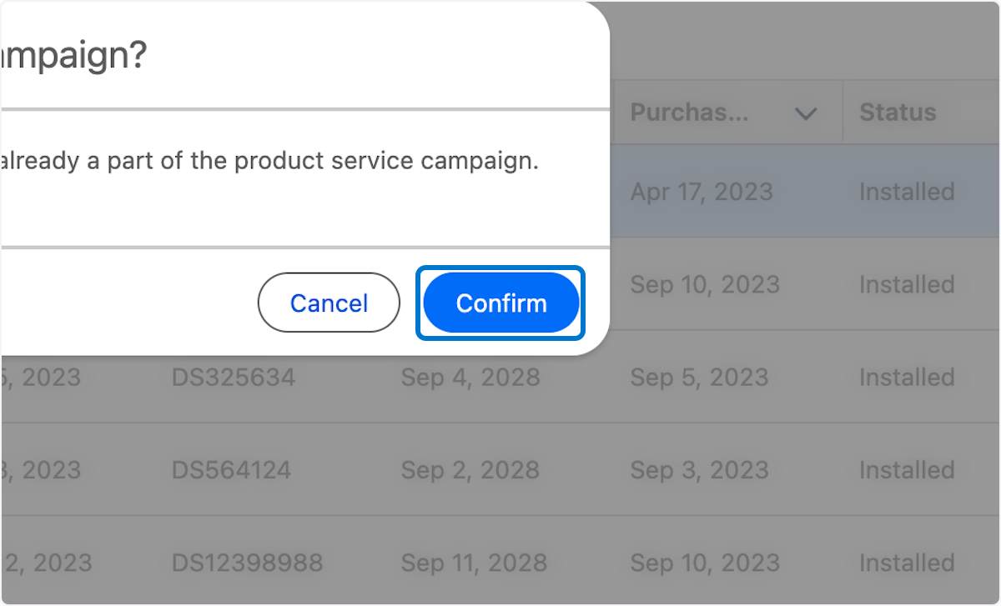

57. Success - Assets are added
Note you may get an error here on redirect to the previous product campaign but the items are added as this org is not Generally available. This is related to the demo env itself.
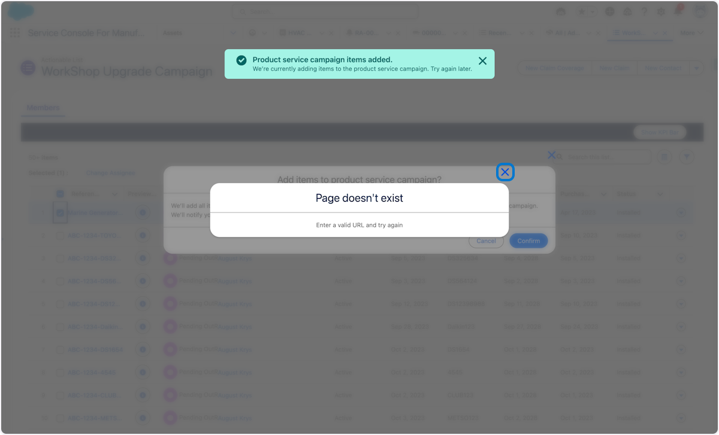

58. 1. Navigate back to the Product Service Campaign from App Launcher 2. Click on Related 3. Verify the Assets are added
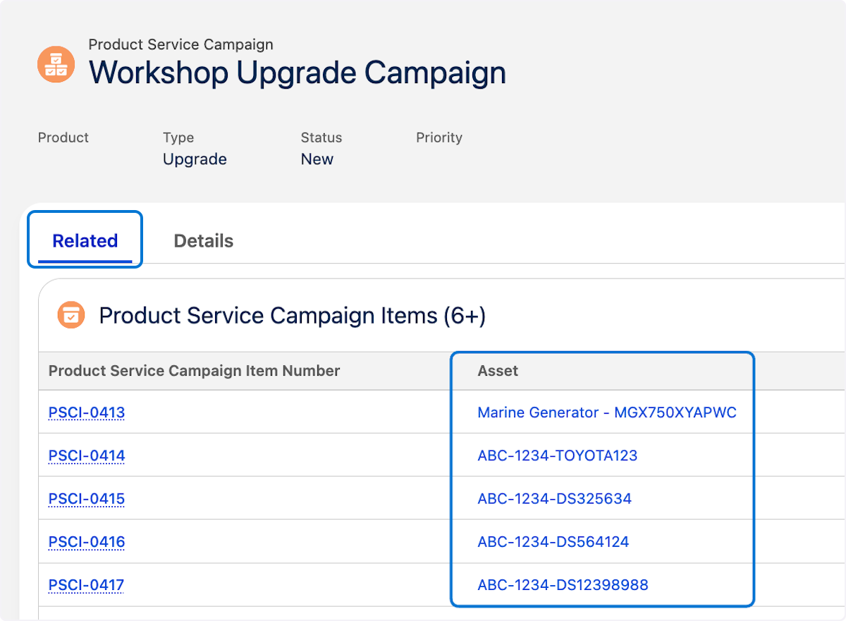

59. 1. Click the action carrot and Select "create work order for all items" 2. Click confirm button
The Final Step is to create work order in mass to support the cross-sell upsell efforts and get techs onsite. The great news is this is done is mass again for all assets added to the campaign
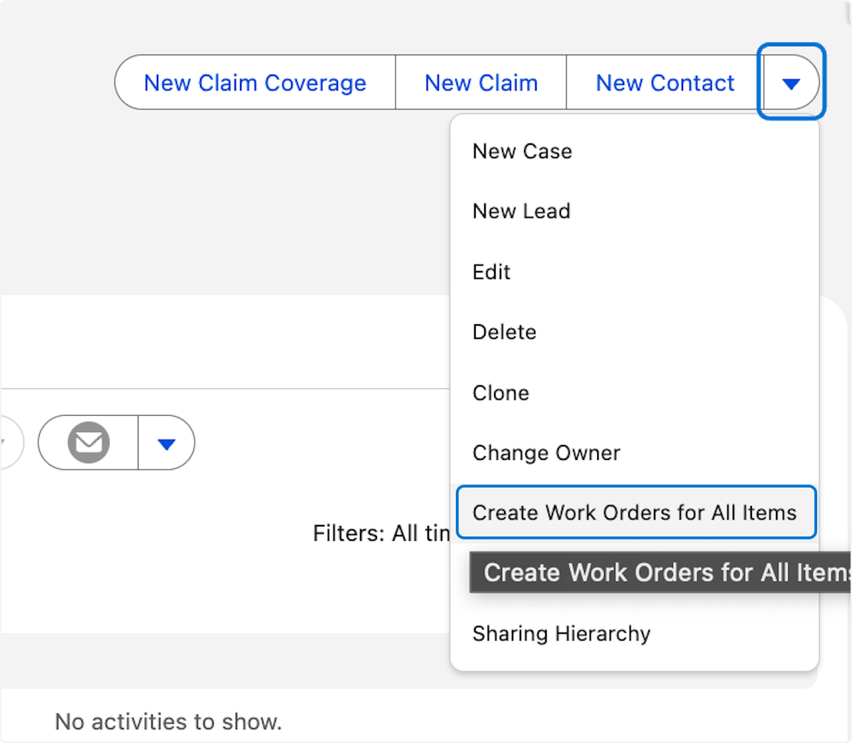

60. 1. Verify created work orders
Congrats on completing this exercise
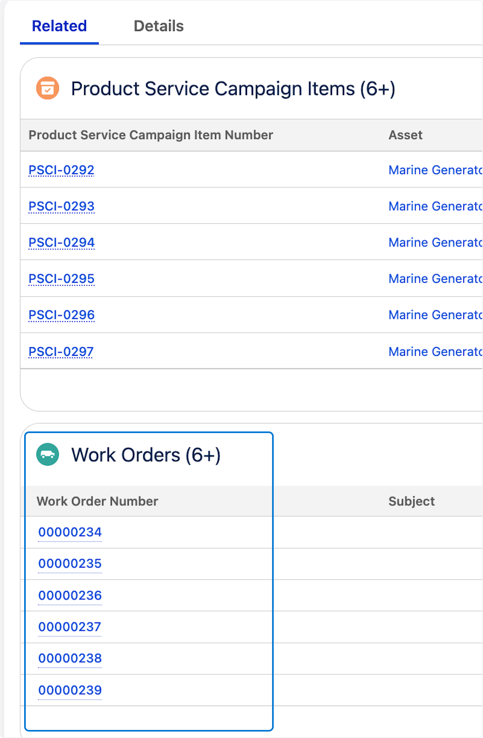

Congratulations on successfully completing the hands-on workshop on Product Service Campaigns in Automotive and Manufacturing Cloud!

Your enthusiasm, participation, and commitment to learning made this workshop a success. You have now acquired valuable skills in building data sets with Data processing engine, Building Actionable Lists, and connecting Product Service Campaigns, crucial for your work in the automotive and manufacturing industry where tackling recalls and upgrades is critical .

Keep experimenting with what you've learned today, and don't hesitate to leverage the additional resources provided for further exploration and mastery.

We look forward to seeing how you apply these new skills in your roles and contribute to your projects' success.

Thank you for your participation, and best wishes on your continued journey with Salesforce!

Warm regards,

August Krys & Team
Director, Industry Solutions Architect
Automotive & Manufacturing Cloud
Salesforce



Want to learn more?

As the capabilities of Salesforce Connected assets and vehicles continue to expand, Salesforce is providing a growing set of enablement offerings to help customers maximize the value of the industries. A wide range of resources are now available to learn more about getting started with connected and utilizing its advanced features such as context service to bring the power of external data , CRM data and AI in a single Platform.







Trailhead Manufacturing Automotive
Trailmix Learning Trial Learning Trial






